To achieve this file listenr functionality we need to achieve 6 rules

CSV File

Service package

Service File

Parse Delimited

Activity

File Listener

First we need to prepare a CSV file with the properties that we would be needing

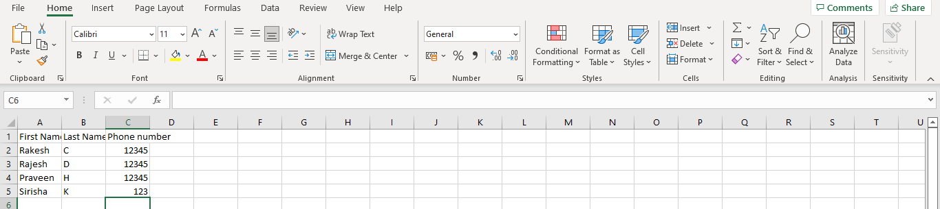

And then we can use data type in the pega as personal data

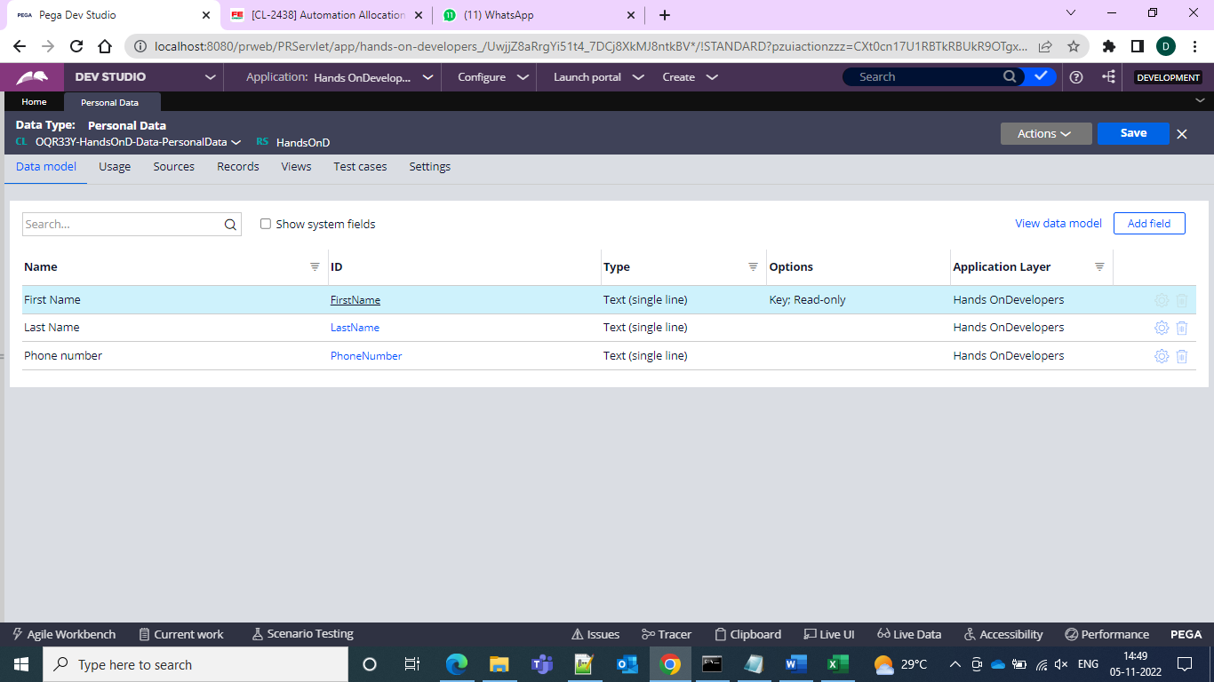

Then create one single page property under work class with the page reference as data class

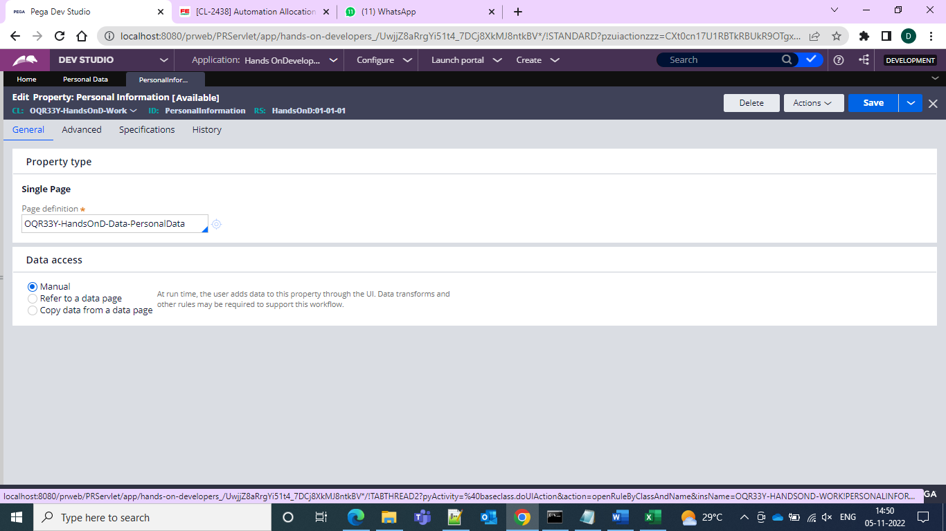

And after that create service package from the records

Inside it give the access group and uncheck the require authentication

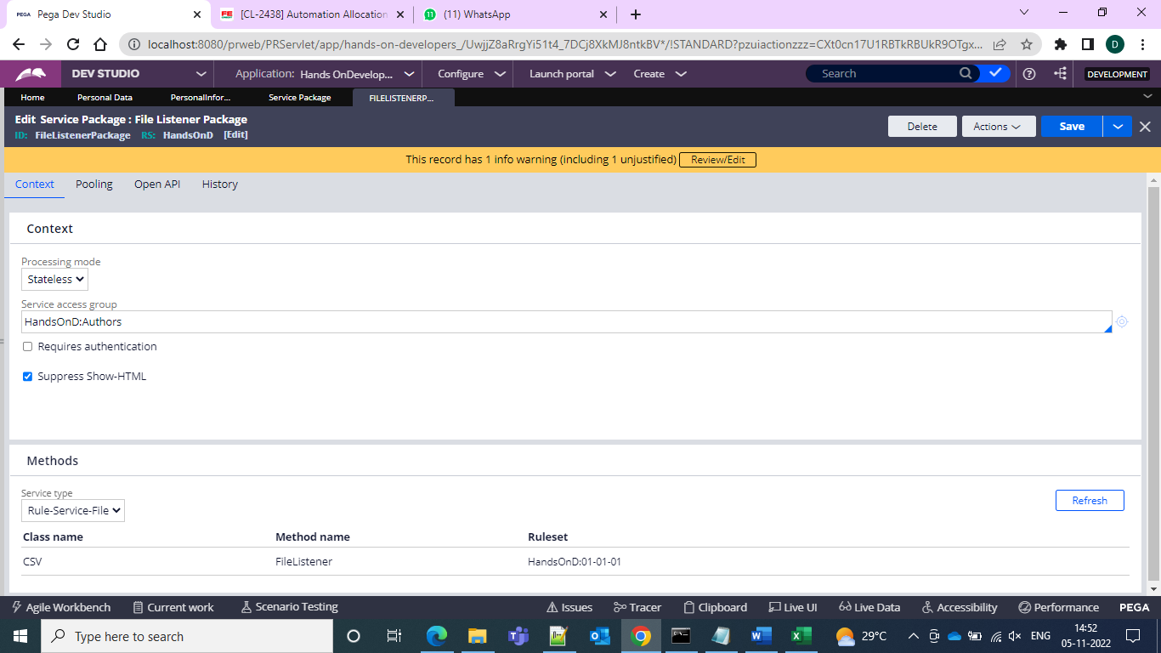

and now create service file package

and in this by default it would be as the MyServicePackage only as the page name and give the work class in the primary page class

and in the method tab give the processing method as record at a time

and give data mode as text only

and give the record terminator as \n

and now in the parse segment give as the map to rule as Parse deleimiter rule will be available in the dropdown and in the Map to key opens a rule as parse delimited we can open the rule and give as CSV rule

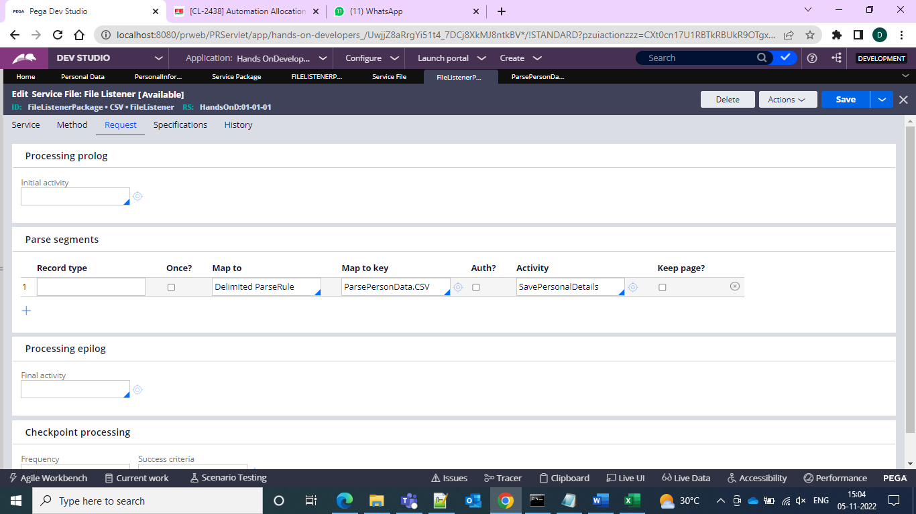’ 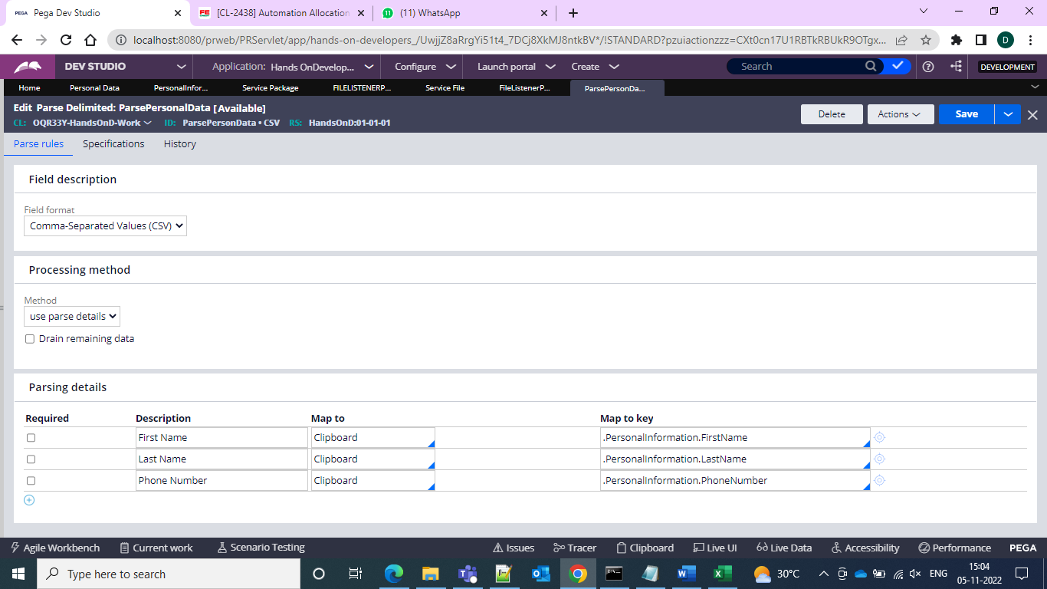

And in this parsing details we can use the description and map to and map to key as below

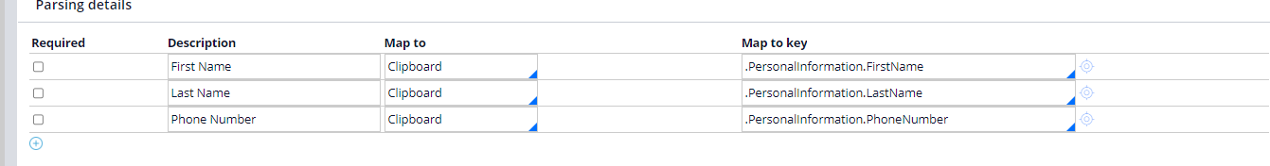

And now create one folder in c drive

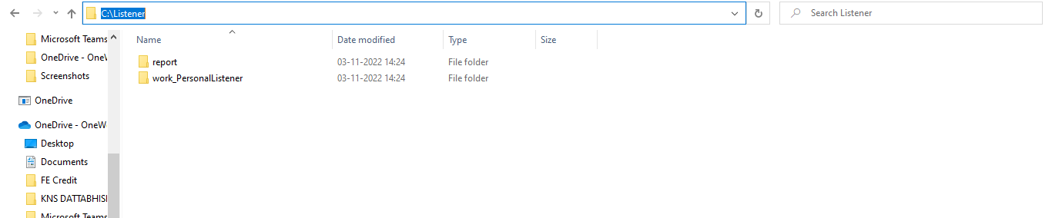

and now create file listener in it and then go for the pasting in the file listener and then give the startup as run on all nodes and then gtive your C drive location and source name as \*.csv

And in the listener properties and in the service package as the package which we created and then go for the service class and service method

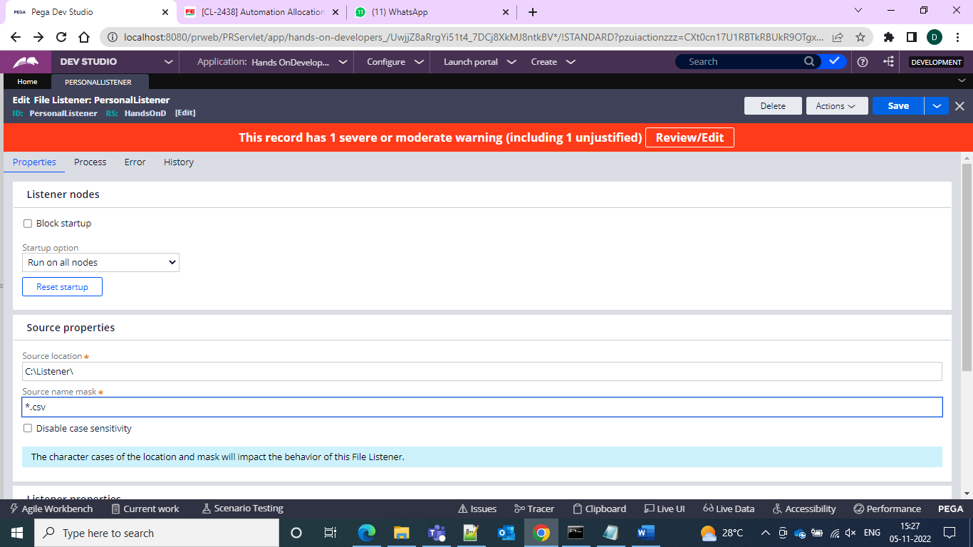

and then can create one activity to save the records to the data type

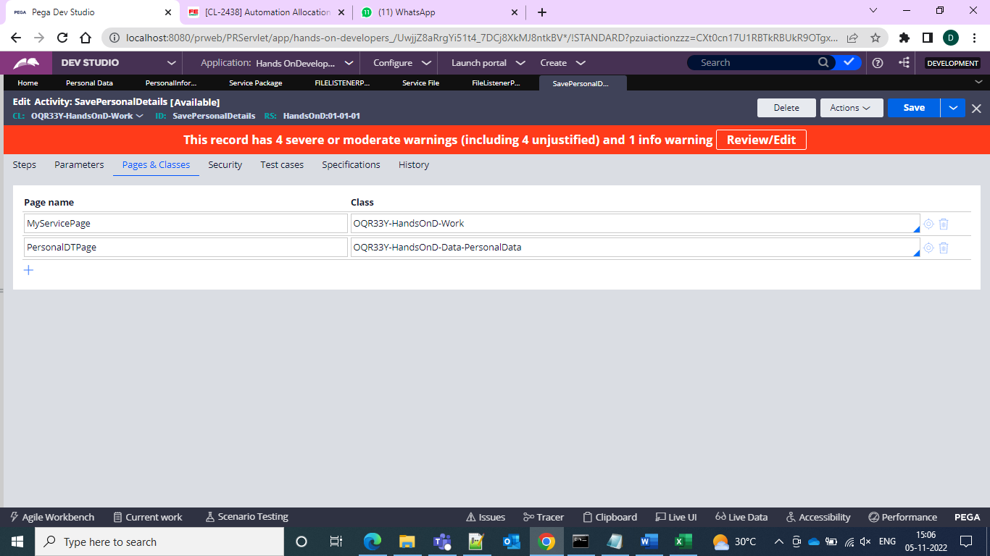

And in this we have the Page Name and as The work class page MyServicePackage and create one temp page for the data class

And now in the activity and then give for the Page-new method declare the Step Page and now copy the same page to the personal information page and into the temp crreated page PersonalDTPage and use Obj-Save use WriteNow to see the results at the same time

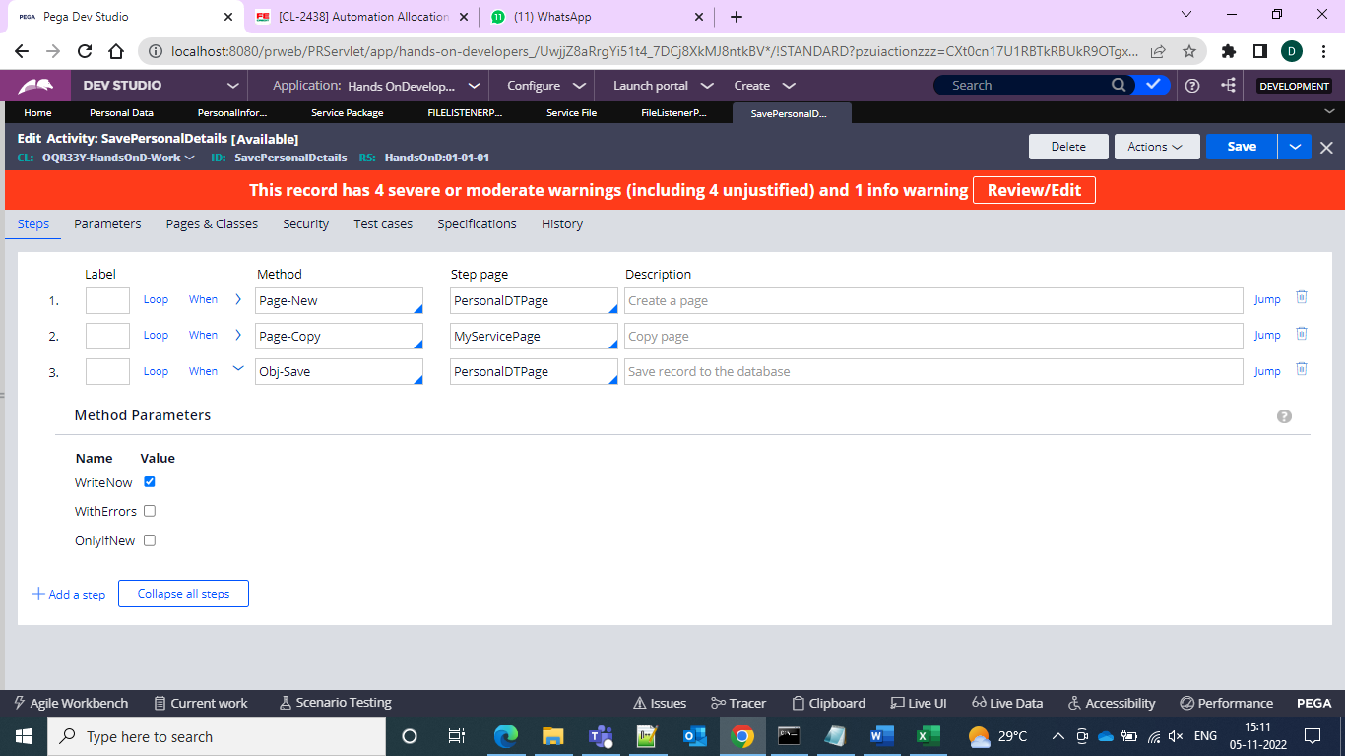

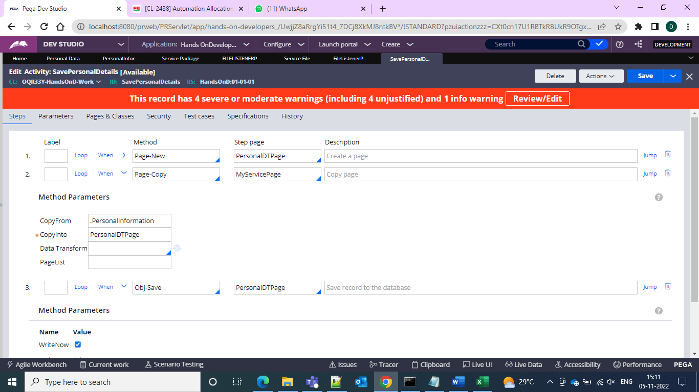

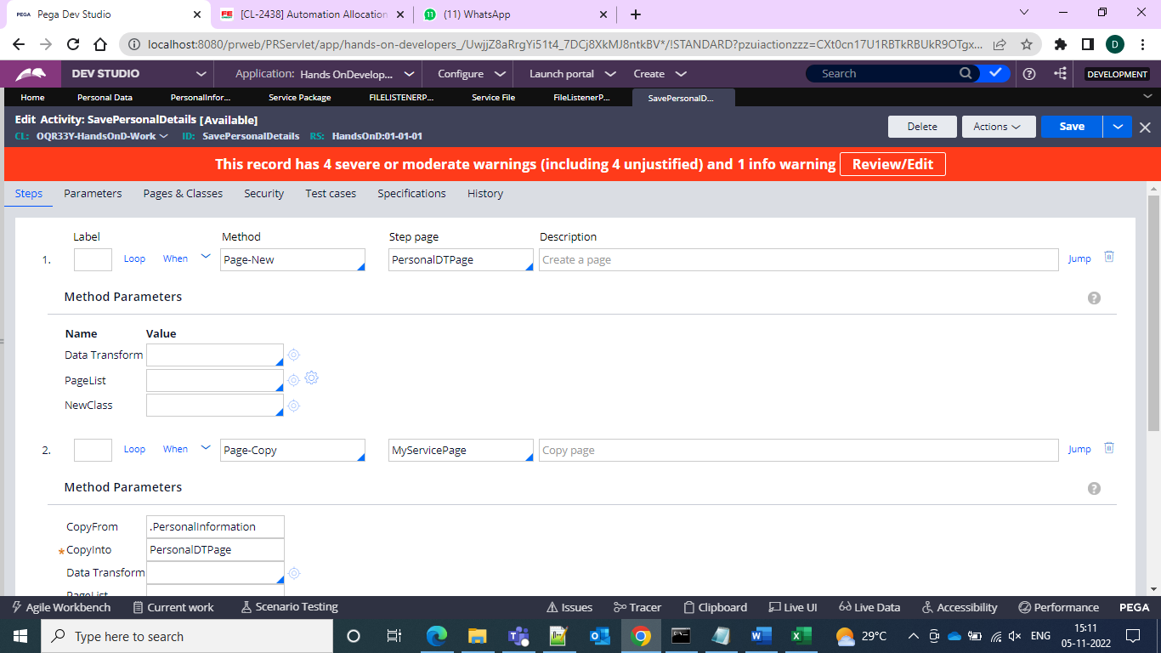

And now go to the admin studio and check for the listener is running or not go to the admin studio

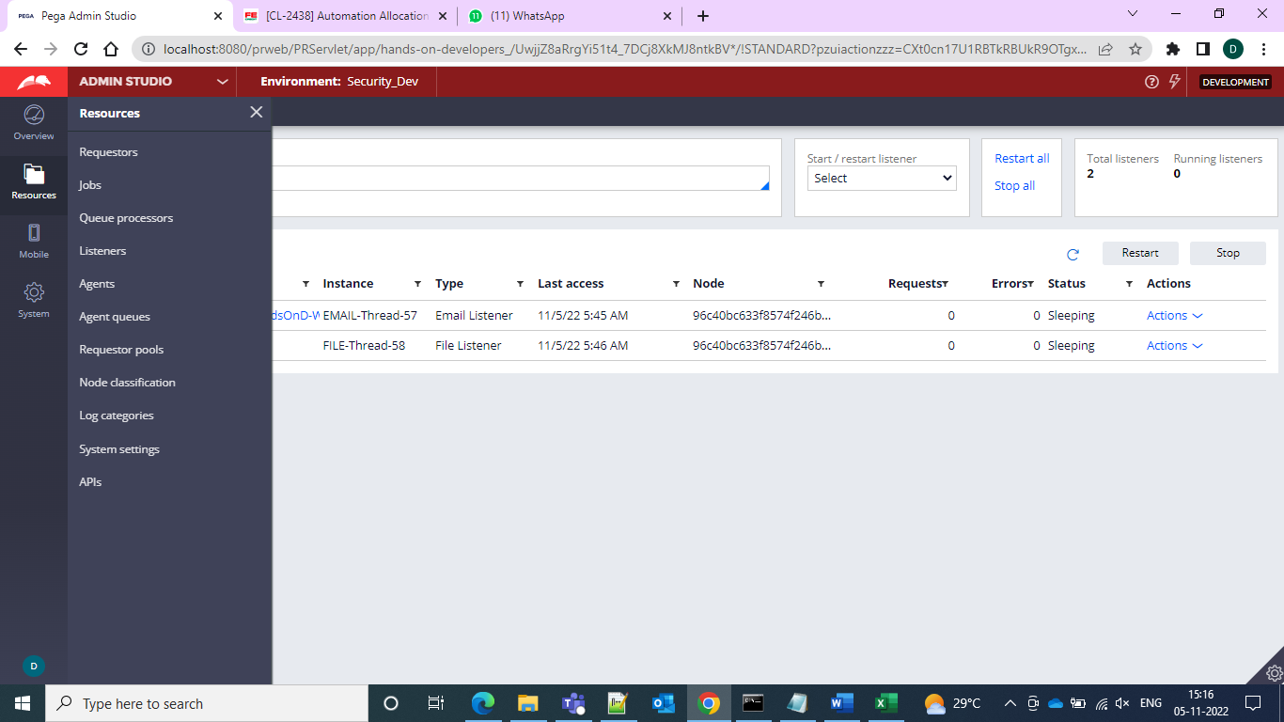

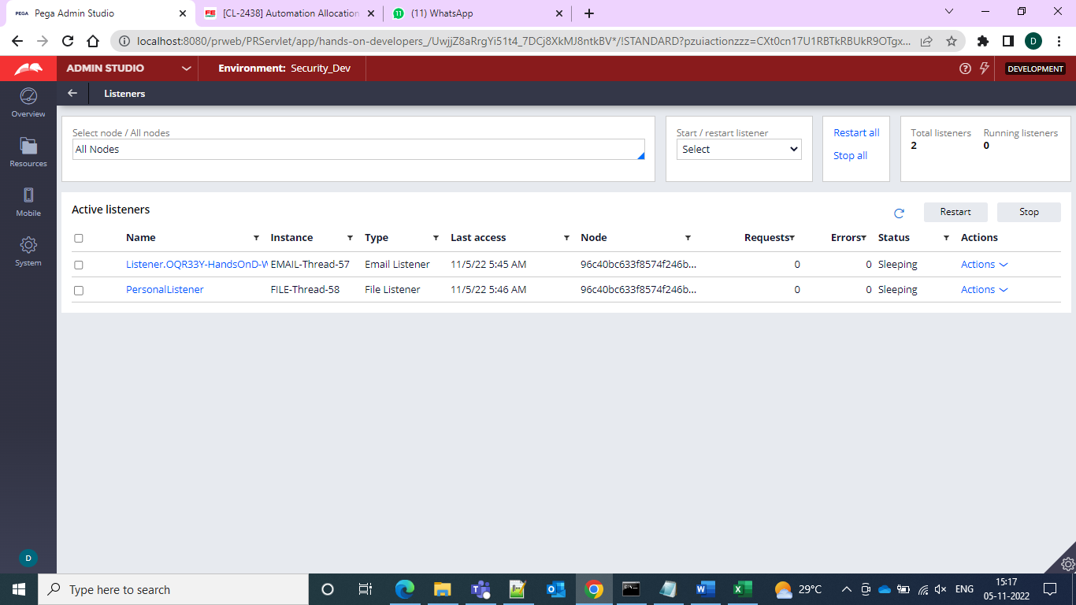

And then run the service file and then run the service file and uplosd the CSV format excel file

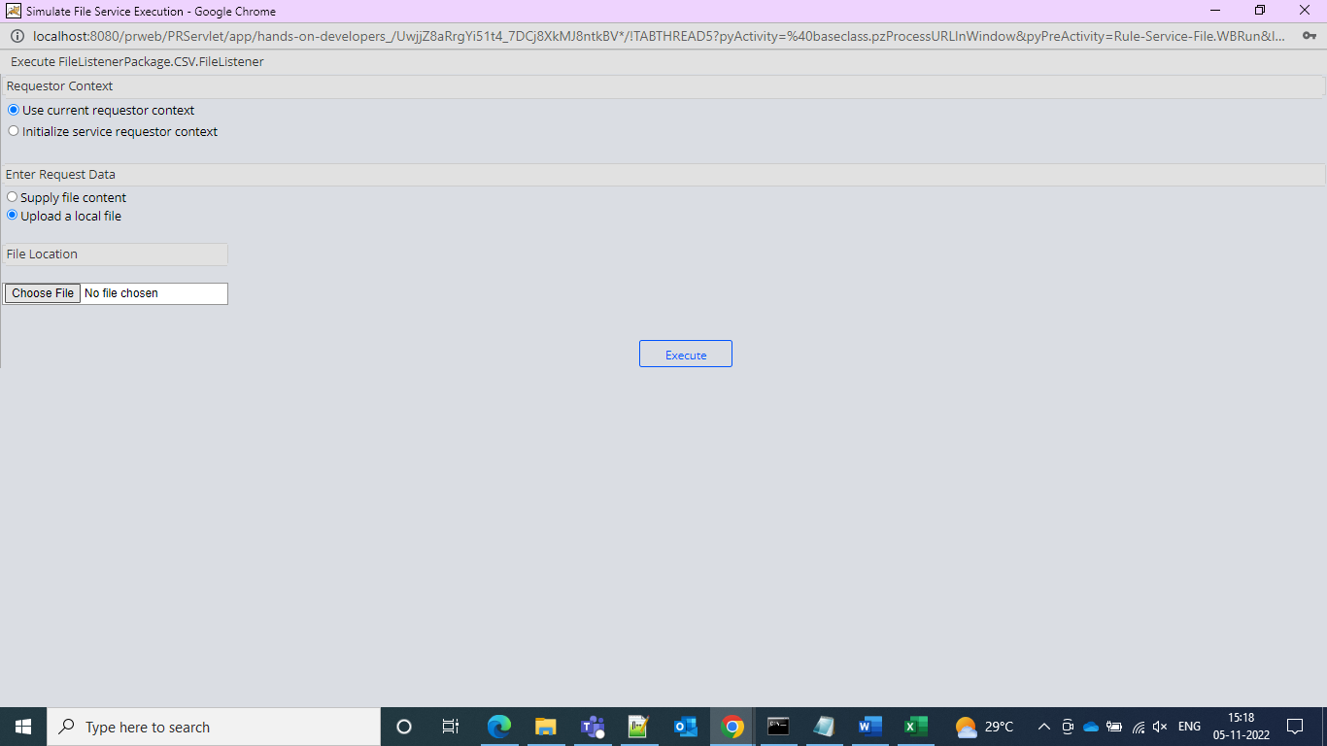

and then after uploading please check the data type records

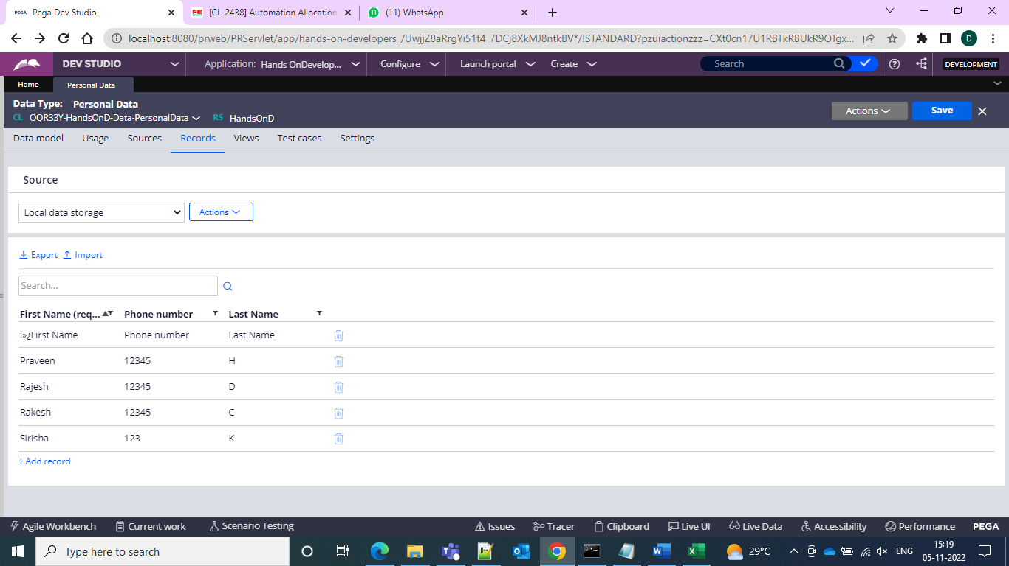

Wohoo the records are inserted

And the execution process would be as below

File Listener:

-------------

-->File Listener will listen the file from Application server path or Destination location and process the file with the help of Service File.

Pega Application<----File-------Application Server Path

-->To Process the File from Application server path or Destination location we need to create below rules

1.Create Properties

2.Create Service Package file

------------------------------

-->In a Service Package we need to provide the Process mode(StateLess or StateFull),Access group and Authentication

3.Create File Listener rule

--------------------------

-->File Listener will listen the file from Application server path or Destination location and process the file with the help of Service File.

-->In a File Listener we need to specify the Destination Path , Type of file to process and Service File.

4.Create Service File rule

---------------------------

--->By Using Service File we can process the file content into the pega application to insert the data into the data base tables or Create a Cases in pega

--->In Service File we need to call the Parse Delimiter rule and activity

5.Create Parse Delimiter rule

--------------------------------

-->By Using Parse Delimiter rule we can convert the Comma seperated data to Clipboard.

6.Create Activity

-----------------

In a Activiity we need to write busilogic to insert the data into the data base tables or Create a Cases in pega

Note: By Using "svcAddWorkObject" predefined activity we can create work objects through activity